Summer Vacation Assignment, 2024-25
Class: IX
Subject -English
1.Learn difficult words and their meanings and all the question - answers of the taught chapters.
2. Define literary devices used in the poem 'The Brook' with examples in H.W. notebook.
3. Design a cover page for your English Literature Reader book or any other book which you have read on a chart paper.
4. Write a book review on "IGNITED MINDS" written by A.P.J. Abdul Kalam in a stick file.
Note : There will be a Book Review Competition just after the summer vacation.So, the students should prepare a decorative project in writing and come prepared for speaking .
5. Make a working model on verb forms.
6. Make a chart on Narration in a decorative way.

CLASS 9 (MATHS)
Where to do–In A4 Size paper,album from colourful paper
Aim– To provide basic knowledge and create interest in Maths
Assignment and Project–
1.To draw hermit crab by constructing square root spiral
2. To draw one square root spiral using mandala art.
Question 3: Do question number 2 and 5 from Rationlisation of exercise 1.4 according to new edition and 1.5 according to old edition.

Question 4: If x = 3 + 2√2, then find the value of √x – 1/√x.
5. Assertion and Reason Questions
i)Assertion: 7 is rational number
Reason: square root of all rational number is irrational.
a.) Both Assertion and Reason are correct and Reason is the correct explanation for Assertion
b.) Both Assertion and Reason are correct and Reason is not the correct explanation for Assertion.
c.) assertion is true but the reason is false.
d.) both assertion and reason are false.
ii) Assertion: Between 1/7 and 2/7 only five irrational number are present.
Reason: Every rational number between limited irrational number are present.
a.) Both Assertion and Reason are correct and Reason is the correct explanation for Assertion
b.) Both Assertion and Reason are correct and Reason is not the correct explanation for Assertion.
c.) assertion is true but the reason is false.
d.) both assertion and reason are false.
iii) Assertion: sum of two irrational numbers 5+√3 and 7+√3 is a irrational number.
Reason: if the product of two irraational numbers is rational the each one is called the rationalizing factor of other.
a.) Both Assertion and Reason are correct and Reason is the correct explanation for Assertion
b.) Both Assertion and Reason are correct and Reason is not the correct explanation for Assertion.
c.) assertion is true but the reason is false.
d.) both assertion and reason are false.
iv) Assertion :19^9÷19^8=19
Reason: if a>0 be a real number and p and q be rational number then a^p÷a^q=a^p-q
a.) Both Assertion and Reason are correct and Reason is the correct explanation for Assertion
b.) Both Assertion and Reason are correct and Reason is not the correct explanation for Assertion.
c.) assertion is true but the reason is false .
d.).Both Assertion and Reason is false
v) Assertion: (5^7)^3=5^21
Reason: 9 is a irrational number
a.) Both Assertion and Reason are correct and Reason is the correct explanation for Assertion
b.) Both Assertion and Reason are correct and Reason is not the correct explanation for Assertion.
c.) assertion is true but the reason is false.
d.) both assertion and reason are false.

6. Prepare one album from chapter Polynomials in which definition,types of polynomials, identities has been shown in artistic way.
Learning Outcomes–Students can learn to share information, defend arguments and communicate the beliefs and desires. By preparing album students can express result of mathematical operations. Students can understand the square spiral root structure in different objects in nature.

Summer Vacation H/w
Class – 9 IT
1) Explain the elements of communication cycle.
2) Explain the type of communication skills.

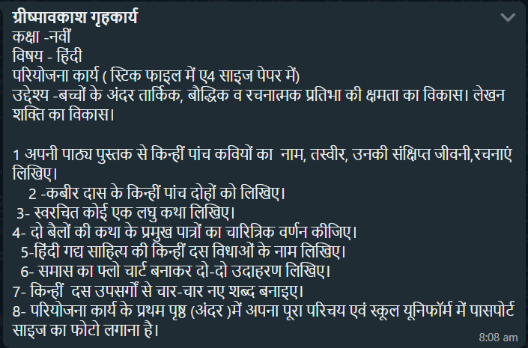

Class IX Economics Summer Vacation Assignment
1. Prepare a comprehensive and an art integration project on Economic development of palampur and compare it with the development of any village of Koderma comparison w
2. Write 10 questions in separate summer vacation home work notebook including 3 MCQ'S, 3 Short Answer type and 4 Long Answer type questions from any reference book of Ch-1.

SUMMER VACATION ASSIGNMENT FOR CLASS IX : (HISTORY/POL.SC) (word limitations -600-800 words) SUB-HIS./POL.SC Where to DO- Project(A4 Size one side rule and one side white page) ,For MCQ questions-Thin Notebook AIM- Grasp the concept Democracy and Importance of Democracy and non democratic country. Learning Objective-Recognize the different rulling system of different types of government.

SUMMER VACATION HOME WORK
CLASS -9 (Geography)
Q1:Make a project on Natural Disaster management
Q2:Complete the Map Pointing work of chapter 1
Q3. Answer all the questions of chapter -1(Geography) in portfolio copy.

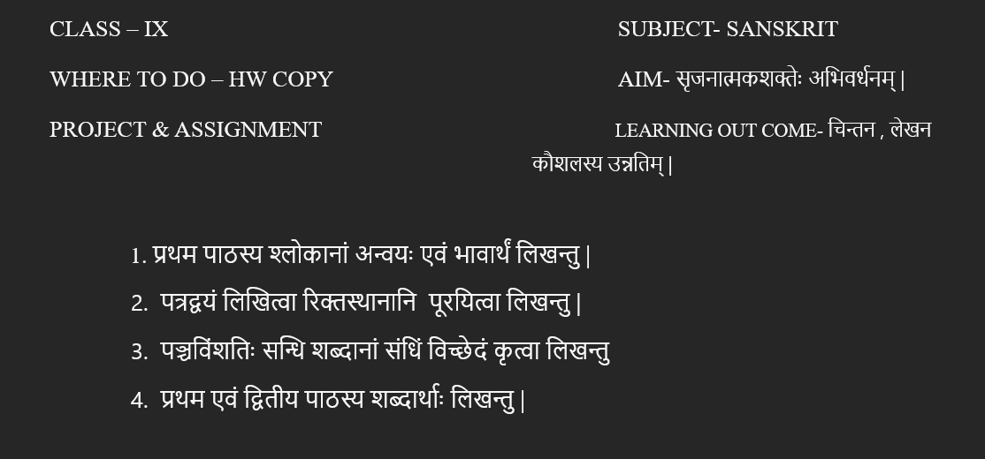

SUMMER VACATION HOMEWORK -2024/25
CLASS – IX SUBJECT - CHEMISTRY
- Model of state of matter .
- Show the intermolecular force between the particles of matter . In activity copy by using colour paper .
- On the topic – “ Latent heat “ make 5 reasoning questions in HW copy .
- How the states of matter interchanges by increasing or decreasing temperature .
Show it with an activity .
- Do the praticals in lab manual copy
- Particles of matter are very small .
- Diffusion process
- Melting point of ice
- Boiling point of water .

CLASS – IX SUBJECT – BIOLOGY
- Model of PLANT CELL or ANIMAL CELL by using biodegradable materials .
- Make a video of the activity - Exo osmosis and Endoosmosis . ( Explain it with school uniform )
- Collect the picture of any five biologist whose discover related to cell and paste it in portfolio copy .
- Prepare the model of Mitochondria .
- Prepare 20 objective questions , 5 assertion reason type questions and 2 case study questions . Submit it in stick file .
- Learn chapter 5 – The fundamental unit of life –CELL for pt – 1 exam .

