SUMMER VACATION ASSIGNMENT, 2024-25
SUBJECT - ENGLISH
CLASS -VI
Aim : To develop student's vocabulary, boost artistic qualities of students through creative projects, develop critical thinking skills .
Learning Outcome: Students will be able to read and comprehend effectively, students will gain exposure to wide variety of words,
students will learn the art of creative diary writing.

1. Word Jar - Make a word jar and write a new word inside the jar everyday during your summer vacation in an A4 size sheet.
Where to do : A4 size sheet and then paste in H.W copy
2. Design a cover page for the story "HOW DADDY DECIDED WHAT HE WANTED TO BE"
Where to do: A4 size sheet and then paste in H.W copy.
3. Make a working model on Prepositions/ Noun .
Where to do: Chart Paper
4. Find and write 20 verbs from Ch-1 and divide them in the category of Regular and Irregular verbs
Where to do: H.W copy
5. Learn and write HOTS of Ch 1 and 2
Where to do : H.W copy
6. Write a diary entry describing your experience of how you spent your summer vacation.

Where to do : H.W copy

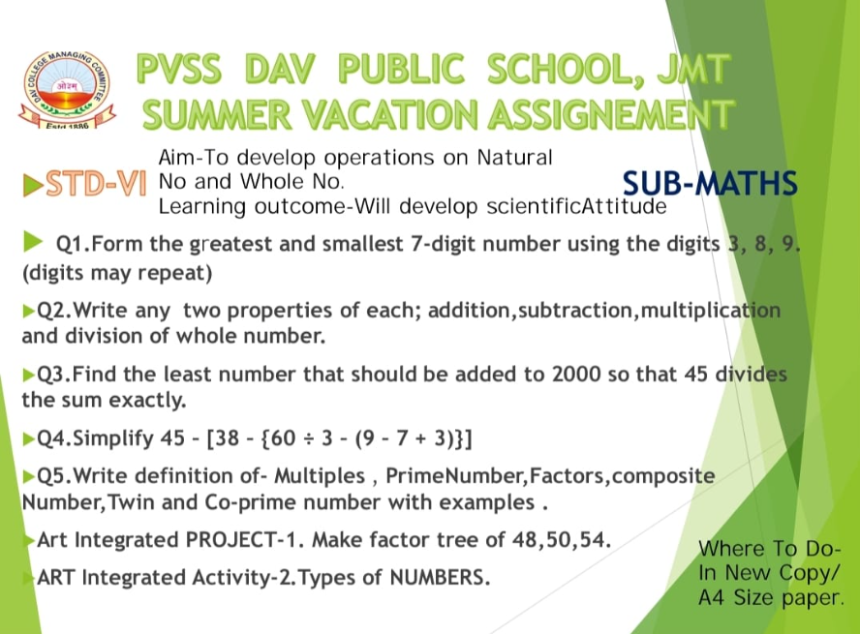

SUMMER VACATION ASSIGNMENT 2024
CLASS—VI. SUBJECT – SCIENCE
1) Make creative things using waste materials like empty bottles, old envelope,waste boxes and old newspaper.
2) Paste the pictures of atleast two environmentalist and write few lines about them in H.W copy
3) Make a model to show the arrangements of particles in the three state of matter.
4) Learn question and answer of taught chapters.

Aim :- TO develop sense of responsibility towards nature.
Where to do :- In H.W copy
Learning outcomes:- Students will get the clear concept of chapter taught.

CLASS 6 SUB.- COMPUTER
- Draw a neat and clean labeled & colourful diagram of ATM.
- What do you mean by an Application Software ? Also explain about its different types.
- Differentiate between Open Source Software and Proprietary Software.
- Describe about different steps needed for creating a presentation, including Slide Design (with required diagrams).
- List the required steps needed for SELECTING BACKGROUND STYLES, in OpenOffice.Org Impress (with diagrams).
- Describe the steps needed for Inserting images in a Slide from File (with colourful diagrams).
(Do it in a separate thin copy)

CLASS 6
SUB : SOCIAL SCIENCE

PROJECT/ ASSIGNMENT

1.Prepare a working model of CHANDRAYAAN 3.
2. Make different tools made by early man.
3. Prepare a chart showing diversity of India.
4.Collect pictures related to the landing of man on the moon and make a scrap file.
You may also collect information about dates on which certain celestial bodies like Mars were seen from the earth.

MAP WORK -

5. Do the map work of ch 1 , 8 and 21.

AIM:
● To make the learning as well as understanding and grasping of the content very easily.

Learning outcome -
● Students will understand the concept of celestial bodies.
● Students will be able to explain ancient tools .
● Students will understand the diversity of India.

