Summer Vacation Assignments :
Class : XII
Sub. : English
Session: 2024 - 2025
1. Write and learn word meanings of new words, summaries and write the questions/answers of the taught lessons.
2. Write five examples of each of the following items :
I. Notice
II. Invitation
III.Formal letter
IV.Article
3. Book Review Writing and Speaking Activity :
Prepare a book review of the book entitled, " You Can" by
George Matthew Adams.
Note : There will be a Book Review Competition just after the summer Vacation.
So, the students should prepare a decorative project both in writing and speaking mode.
4. Prepare a beautiful project on different literary devices with suitable examples and learn them. Make a video of this project work.

XII-SC. SUB- PHYSICS
AIM- To enhance critical thinking ,numerical ability and scientific skills.
Where to do- H.W. COPY.
1. Write all physical quantity ,its formula and its SI unit of chapter electrostatics and electricity.
2.Plot all graphs given in N.C.E.R.T intext using pencil.
3.Solve 50 M.C.Q. and 20 Assertion –Reason type questions of above chapters from previous year CBSE questions .
4.SOLVE 20 Questions ( Numericals and C.B.Q.) from previous year cbse questions.
5.Revise and practice all derivations of above chapters.
Learning outcomes: students are able to draw the graph and interprete it.
It increase evaluation skills, critical thinking skills .

CLASS-STD-XII SUB-CHEMISTRY
AIM- To get the basic concepts and knowledge of solutions and applications of solutions.
WHAT TO DO- Q1 Prepare concept map for colligative properties from solution chapter.
Q2 Calculate the mole fraction of water in a mixture of 12 g water, 108 g acetic acid and 92 ethanol.
Q3 Calculate the molality and mole fraction of the solute in aqueous solution containing 3 g of urea per 250 g of water.
Q4A solution of glucose (C6H1206) in water is labelled as 10% by weight. What would be the molality of the solution?
Q5Vapour pressure of pure water at 298 K is 23.8 m m Hg. 50 g of urea (NH2CONH2) is dissolved in 850 g of water. Calculate the vapour pressure of water for this solution and its relative lowering.
Q6
Q7
Q8 DIFFERENTIATE BETWEEN POSITIVE AND NEGATIVE DEVIATION FROM RAOULT’S LAW WITH GRAPH ALSO.
Q9 Calculate the cell potential of the given cell at 25°C. (R = 8.31 J K–1 mol–1, F = 96500 C mol–1).
Ni (s)|Ni2+(0.01 M) || Cu2+ (0.1 M)|Cu(s) Given: E0Cu2+/Cu = + 0.34 V E0 (Ni2+/Ni) = – 0.25V
WHERE TO DO: IN H.W COPY
LEARNING OUTCOME: STUDENTS WILL BE ABLE TO SOLVE THE NUMERIALS
AND TO KNOW THE APPLICATIONS OF RAOULT’S LAW

SUMMER ASSIGNMENT [SESSION: 2024-25]
CLASS- XII SUB.- BIOLOGY
Where to do-In Biology Home work copy.
Aim- For better understanding the concept of Sexual reproduction in flowering plants, Human reproduction, Reproductive health.
Project and assignment:-
1) Draw the diagram of a mature em bryo sac and show its 8 nucleate 7 celled nature . Show the following parts- antipodals ,Synergids,egg, Central cell polar nuclei.
2) Are parthenocarpy and apomixis different phenomena? Discuss their benefits.
3) Starting with the zygote draw the diagram of the different stages of embryo development in a dicot.
4) Draw the diagram of a microsporangium and label it's wall layers .write briefly about the wall layers.
5) How is pollination carried out in water plants?
6) The zygote passes through several developmental and stages till implantation . Describe each stage briefly with the suitable diagrams.
7) Draw a neat a diagram of a female reproductive system and label the parts associated with the following a)production of gamete b)site of fertilization c) site of implantation d) birth canal.
8) With suitable diagram describe the organisation of mammary gland.
9) Mention the importance of LH surge during menstrual cycle.
10) What is foetal ejection reflex .Explain how it leads to Parturition.
11) Suggest some important steps that you would recommend to be taken to improve the reproductive health standards in India.
12) What are assisted reproductive techniques practiced to help infertile couples?Describe any three techniques.
13) Enumerate and describe any five reasons for introducing sex education to school going children.
14) Do you justify the statutory ban on aminocentesis in our country .Give reasons.
15) STDs can be considered as a self invited diseases .comment.

Learning outcome-
Students will be able to understand about the different topics of sexual reproduction in flowering plants, Human reproduction and Reproductive health.

SUMMER ASSIGNMENT 2024
Class- 12sci and com
Sub- physical education
where to do-In notes copy.
*Project / Assignment learning outcomees
1.Procedure to draw fixture- knock out of 11and 19 teams.
2.Draw a fixture 5 teams and teams on league basis according to cyclic method. Note you can make in your note copy by seperating / giving heading summer vacation assignment
SUMMER VACATION HOME WORK
CLASS-12 SC SUB- MATHEMATICS
1. Prepare a project on the relationship between Matrices and Determinants.
2.ACTIVITY:To verify that the relation R in the set L of all lines in a plane is defined by R ={ (l,m): l || m} is an equivalence relation.
MATERIAL THAT YOU HAVE TO USE:
- A piece of cardboard
- 8 pieces of wire
- Some nails
- Other material that u need
3. If A= 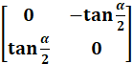. Prove That
(I + A) = ( I – A ) 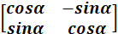
4. Express B=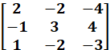as the sum of symmetric and skew symmetric matrix.

5. Find the Inverse of the following matrices
a. A = 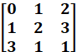
b.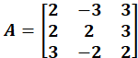

6. I f x y and = 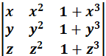 =0 prove that 1+xyz =0.ve t
7. Prove that 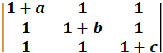= abc (1+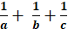) = abc + bc +ca+ ab
8. Prove that 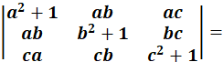 1+ a² + b² + c²
9.Prove that 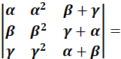()()()()
10. The sum of three numbers is 6 . if we multiply 3rd number by 3 and add second number to it , we get 11. By adding 1st number and 3rd number we get double of the second number. Find number by matrix method. (x=1 , y=2, z=3)
11.If a,b,c are +ve and unequal. Prove that 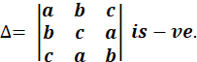
- Use product 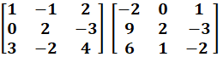to solve the system of equation
x-y+2z=1, 2y -3z=1, 3x-2y+4z =2

13. Prove that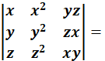(x-y)(y-z)(z-x)(xy+yz+zx)
14.Prove that 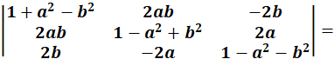(1+a²+b²)³
15. Prove that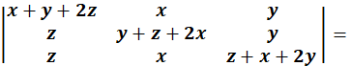2(x+y+z)³
16. If 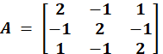prove that A³ – 6A² + 9A- 4I = 0. Hence Find A⁻¹
17. Prove that.
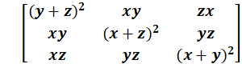 = 2xyz
18. If a, b and c are real numbers &
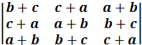 = 0
Show either a+b+c = 0, or a=b=c
19. Prove that
` 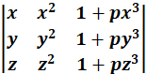 = (1+pxyz) (x-y) (y-z) (z-x)
20. Show that $\left|\begin{matrix}x+1 & x+2 & x+a \\ x+2 & x+3 & x+b \\ x+3 & x+4 & x+c\end{matrix}\right|=0$ where a, b, c are in Arithmetic Progression

