Summer Vacation Assignments :
Class : XII
Sub. : English
Session: 2024 - 2025
1. Write and learn word meanings of new words, summaries and write the questions/answers of the taught lessons.
2. Write five examples of each of the following items :
I. Notice
II. Invitation
III.Formal letter
IV.Article
3. Book Review Writing and Speaking Activity :
Prepare a book review of the book entitled, " You Can" by
George Matthew Adams.
Note : There will be a Book Review Competition just after the summer Vacation.
So, the students should prepare a decorative project both in writing and speaking mode.
4. Prepare a beautiful project on different literary devices with suitable examples and learn them. Make a video of this project work.

12 commerce
B.ST.

FORM A HYPOTHETICAL COMPANY and implement Principles of management
in that company.
In a tag filewhere to do-In notes copy.
*Project / Assignment learning outcomees
1.Procedure to draw fixture- knock out of 11and 19 teams.
2.Draw a fixture 5 teams and teams on league basis according to cyclic method. Note you can make in your note copy by seperating / giving heading summer vacation assignment

Class 12 commerce
Summer Assignment
Macro Economics
Questions and Answers
of chapter 1and chapter 2.
INDIAN ECONOMIC DEVELOPMENT

PREPARE a report on Indian Economic Development for last 10 years

12 commerce
B.ST.
FORM A HYPOTHETICAL COMPANY and implement Principles of management
in that company.
In a tag file

👆Summer Vacation Assignment
Subject - ACCOUNTANCY
Learning outcomes
Students will be able to have deep understanding of fundamentals of partnership as well as adjustments related to change in profit sharing ratio.
To be done In class Notebook
(For rest of the files of 12 Accounts, students should communicate to Pradeep Sir).

Class 12 commerce
Summer Assignment
MATHEMATICS
(students should communicate to subject teacher)

SUMMER VACATION HOME WORK
CLASS-12 COM SUB- MATHEMATICS
1. Prepare a project on the relationship between Matrices and Determinants.
2. For what value of k, points P(3,-2), Q(8,8) and (k,2) are collinear
3. Express B=$\left|\begin{matrix}x+1 & x+2 & x+a \\ x+2 & x+3 & x+b \\ x+3 & x+4 & x+c\end{matrix}\right|=0$as the sum of symmetric and skew symmetric matrix.

4. Find the Inverse of the following matrices
a. A = 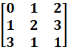
b.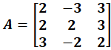
5. a.) Solve the following system of equations using Cramers rule
X+y+z=10 , 2x+y=13 , x+y-4z=0
b) A school plans to award Rs.6000 in total to its students to reward for certain values – honesty , regularity and hard work . When three times the award money for hard work is added to the award money given for honesty amounts to Rs. 11000. The award money for honesty and hard work together is double the award money for regularity. Use matrix method to find the prize money for each category of award.
6. I f x y and = 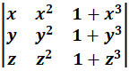 =0 prove that 1+xyz =0.
7. Prove that :-

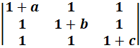= abc (1+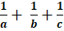) = abc + bc +ca+ ab
8.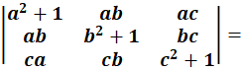 1+ a² + b² + c²
9.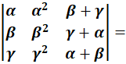()()()()
10.The sum of three numbers is 6 . if we multiply 3rd number by 3 and add second number to it , we get 11. By adding 1st number and 3rd number we get double of the second number. Find number by matrix method. (x=1 , y=2, z=3)
- If a,b,c are +ve and unequal. Prove that 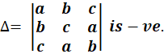
- Use product 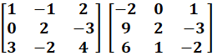to solve the system of equation
x-y+2z=1, 2y -3z=1, 3x-2y+4z =2
Prove that :-
13
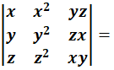(x-y)(y-z)(z-x)(xy+yz+zx)
14.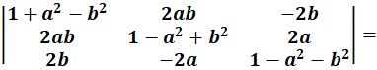(1+a²+b²)³
15.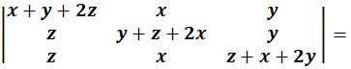2(x+y+z)³
16.If 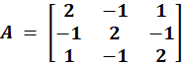prove that A³ – 6A² + 9A- 4I = 0. Hence Find A⁻¹
17. Prove that.
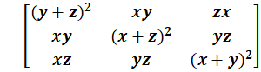 = 2xyz
18. If a, b and c are real numbers &
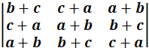 = 0
Show either a+b+c = 0, or a=b=c
19. Prove that
` 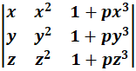 = (1+pxyz) (x-y) (y-z) (z-x)
20. Show that where a, b, c are in Arithmetic Progression
*****************************************************************

