SUMMER VACATION ASSIGNMENT, 2024-25
SUBJECT - ENGLISH
CLASS -X
1. Write new words with meanings and learn all the Question - Answers of the taught lessons.
2. Do 5 exercises of NARRATION from a grammar book in H.W. notebook.
3. Write a book review of the book BELIEVE IN YOURSELF written by Swami Vivekananda in a stick file.
Note : There will be a Book Review Competition just after the summer vacation.So, the students should prepare a decorative project in writing and come prepared for speaking .
4. Give pictorial depiction of 'The Frog And The Nightingale ' and write it's critical appreciation on a chart paper.
5. Project- Make a working model on Poetic Devices. (Atleast 10)

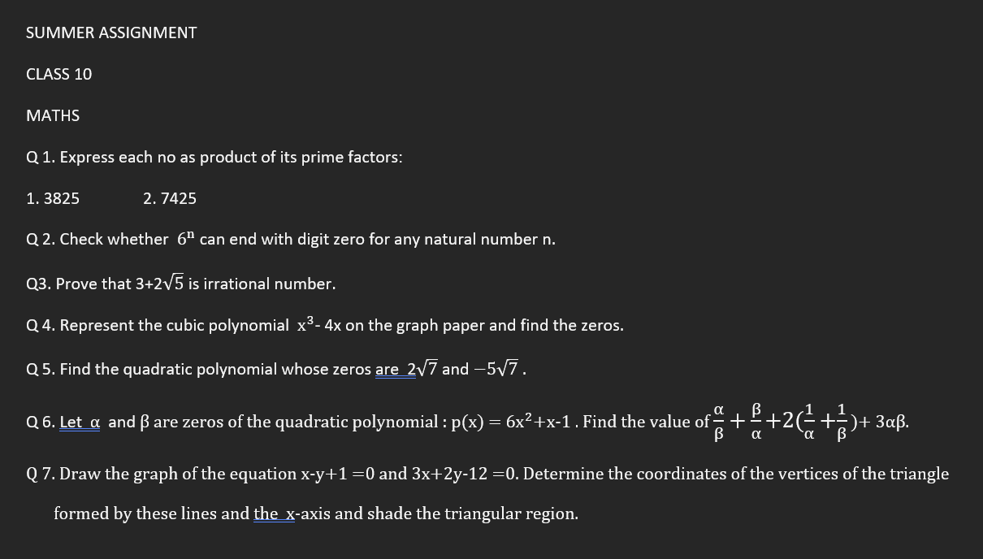

Summer Vacation H/w
Class – 10 IT
1) Solve the all questions from Page no. 3-17 of Lab Manual book

SUMMER VACATION ASSIGNMENT FOR CLASS X:(HISTORY/POL.SC) 1- Prepare a comprehensive Inter-disciplinary project report on the topic "The German Unification/Italian Unification/Power Sharing" (word limitations -800-1000 words) 2-Prepare 5 Assertion -Reason based questions ,15 multiple choice question from History Ch-1 "The Rise of Nationalism in Europe " from the taught part . 3.Prepare 5 Assertion -Reason based questions,15 MCQ questions from Pol.SC. Ch- 1 "Power Sharing".

class-10 SUB-HIS./POL.SC Where to DO- Project(A4 Size one side rule and one side white page) ,For MCQ questions-Thin Notebook AIM- Grasp the concept of nation ,Nationalism and self-determination/ Importance of Power Sharing, Why power sharing is necessary. Learning Objective-Recognize the characteristics of nationalism .

SUMMER VACATION HOME WORK
CLASS -10 (Geography)
Q1:Make a project on Sustainable development
Q2:Complete the Map Pointing work of chapter 1
Q3. Answer all the questions of chapter -1(Geography) in portfolio copy

Economics Home work Assignment
1. Prepare a comprehensive and an art integration project on Economic development of India and its comparison with other countries.
2. Write 10 questions in separate summer vacation home work notebook including 3 MCQ'S, 3 Short Answer type and 4 Long Answer type questions from Ch-1.

SUMMER ASSIGNMENT
STD 10 PHYSICS
Aim: a) To highlight the important topics
b) To visualize the variation of image formed by concave mirror at different position of the object.
c) To explore their creativity by giving project related to art integrated.
Where to do : Portfolio copy.
Assignments: a) To prepare a concept map on reflection of light
b) To draw the formation of images by concave and convex mirror using colourful threads for showing the rays and coloured paper to identify the object and image.
Learning outcome: The students are able to get a clear concept about the variation of image and they are able to solve the numerical based on it.
By creating a concept map, the students can easily correlate the whole topic and their relation by drawing flow chart which is very much useful for the last moment preparation before the exam.

CLASS-STD-X SUB-CHEMISTRY
AIM- To get the basic concepts and knowledge of Chemical reactions and chemical changes. And able to prepare natural indicators by using daily use substances.
WHAT TO DO-
Q1. Draw a Mind Map of chapter-1 ( Chemical reactions and Equations.) (in portfolio)
Q2 Prepare natural indicator with the help of China Rose and Tur meric . use this indicator in acidic(lemon) and basic solution(soap) and paste these stripes in (Portfolio copy)
Q3 Explain different types of reactions and show the examples with the help of colourful papers ( in portfolio copy)
Q4 Do these practicals in lab manual copy:
(i)Performing and observing the following reactions and classifying them into: Unit-I
A. Combination reaction B. Decomposition reaction C. Displacement reaction D. Double displacement reaction (i) Action of water on quicklime (ii) Action of heat on ferrous sulphate crystals (iii) Iron nails kept in copper sulphate solution(iv) Reaction between sodium sulphate and barium chloride solutions
(ii)Finding the pH of the following samples by using pH paper/universal indicator
(i) Dilute Hydrochloric Acid (ii) Dilute NaOH solution (iii) Dilute Ethanoic Acid solution (iv) Lemon juice (v) Water (vi) Dilute Hydrogen Carbonate solution
Learning outcomes:1 To understand the complete chapter in brief by mind map.
- To identify the different types of chemical reactions and indicators in everyday life.

CLASS- X SUB.- BIOLOGY
Where to do - In a cardboard, portfolio copy
Aim- To understand the concept of various Life processes of organisms.
Project or assignment –
1) Make a model of open stomatal pore and closed stomatal pore .
2) Write the mechanism of opening and closing of stomata with diagram.
3) Make a model of human digestive system.
4) Write the steps involved in the nutrition of human being .
5) With a suitable diagram describe the circulation of blood in human body.
Learning outcome - students will be able to understand the concept of various Life processes of organisms.

